**PRACTICAL NO: 04**

**AIM: Use NMap scanner to perform port scanning of various forms – ACK, SYN, FIN, NULL, XMAS**

Enter Ip of target PC

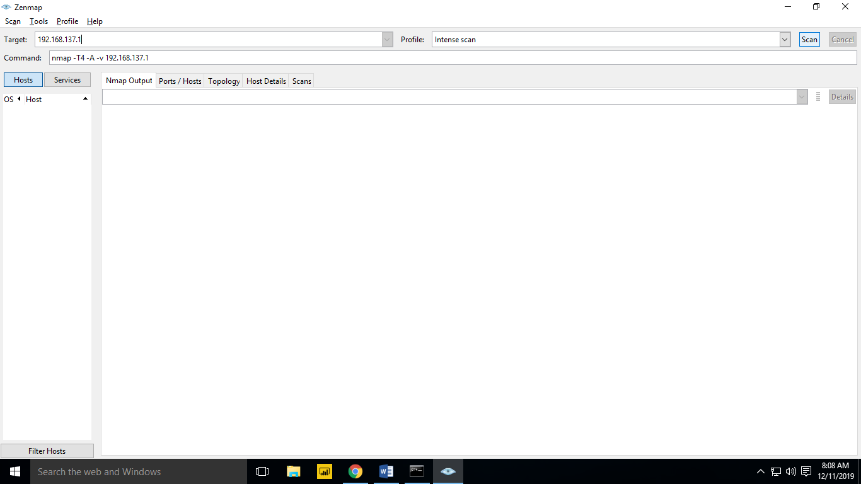

Select Intense Scan From dropdown

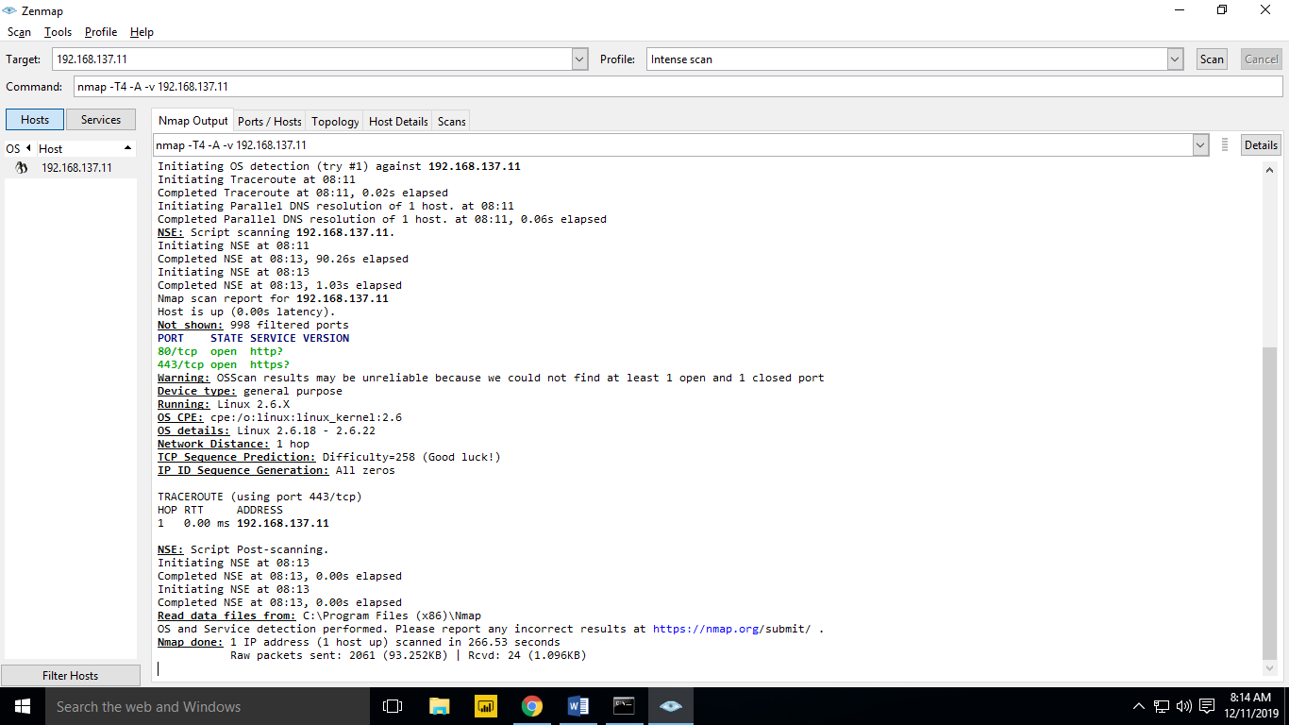

Select intense scan all tcp ports from profile dropdown

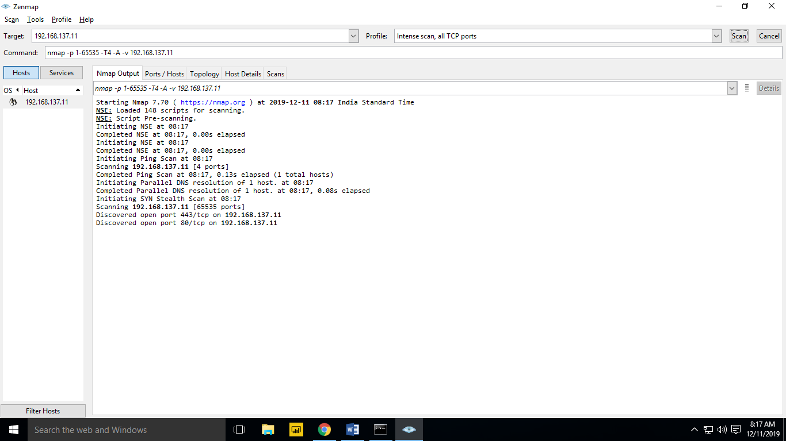

Select regular scan from profile dropdown

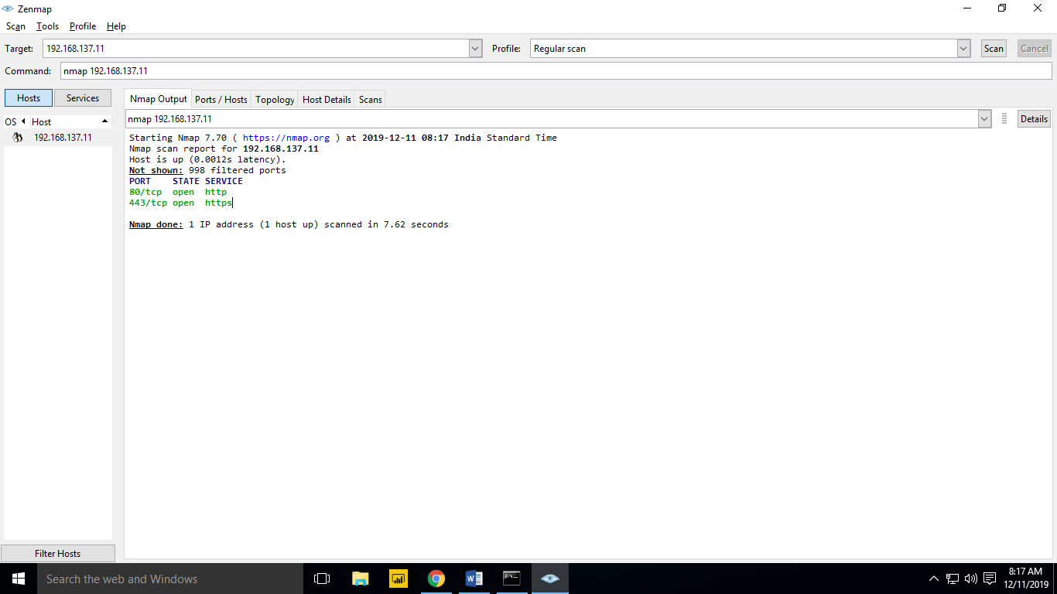

Check Ports and Host

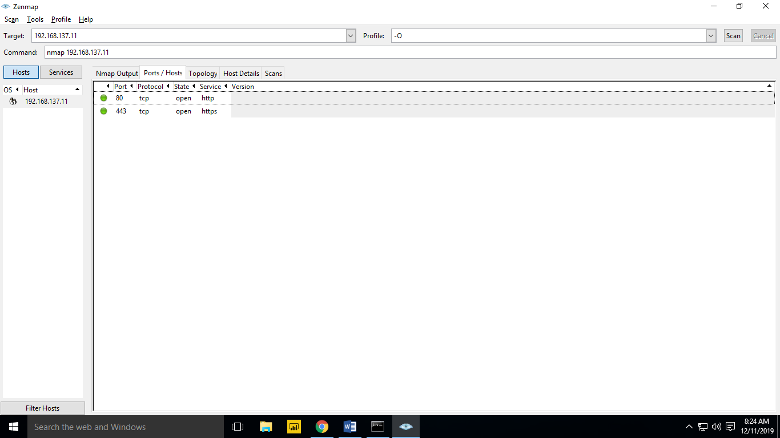

Select Fisheye

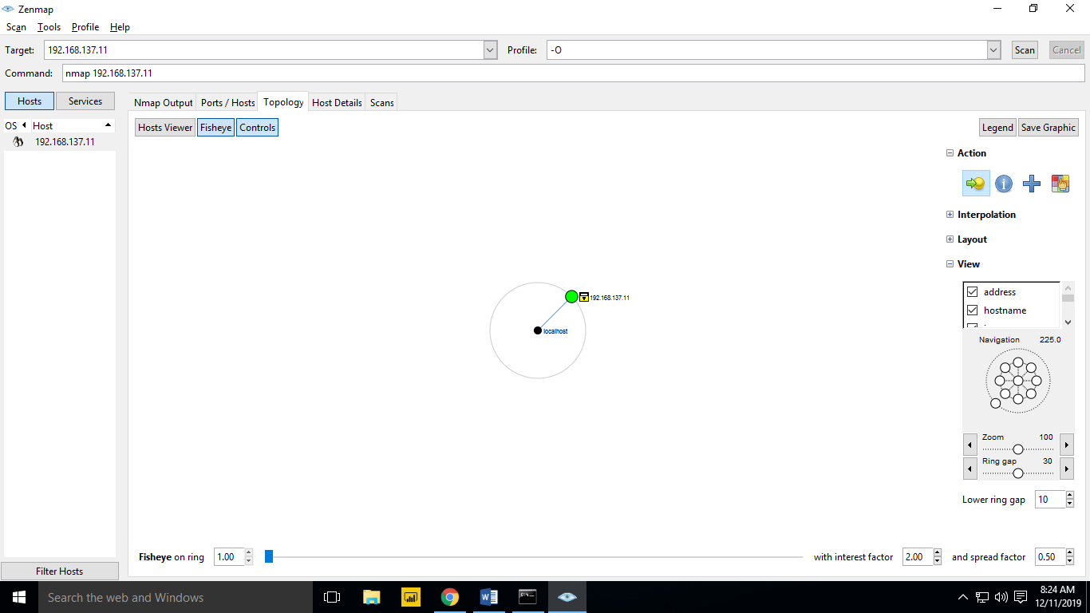

Select Host Details

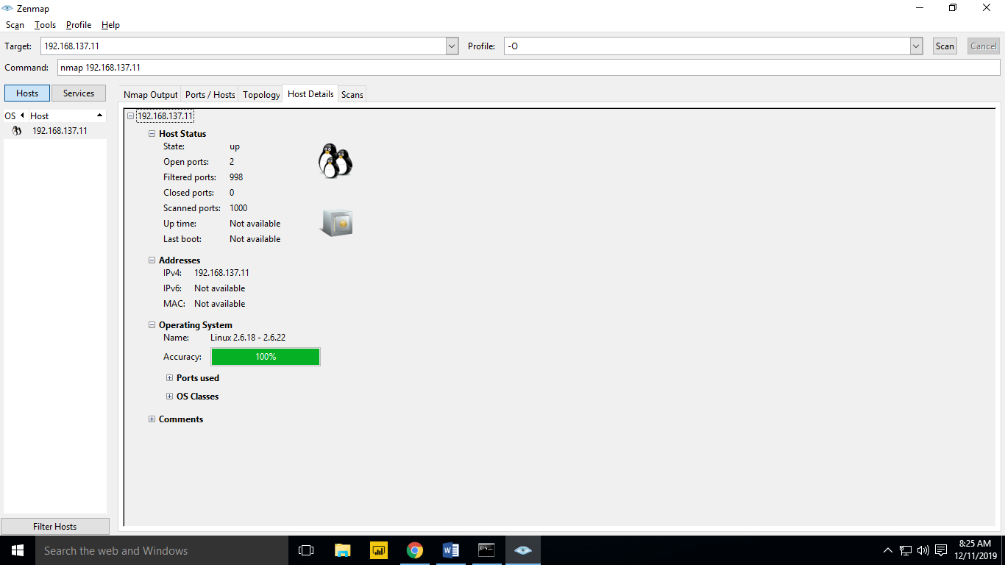

FIN SCAN

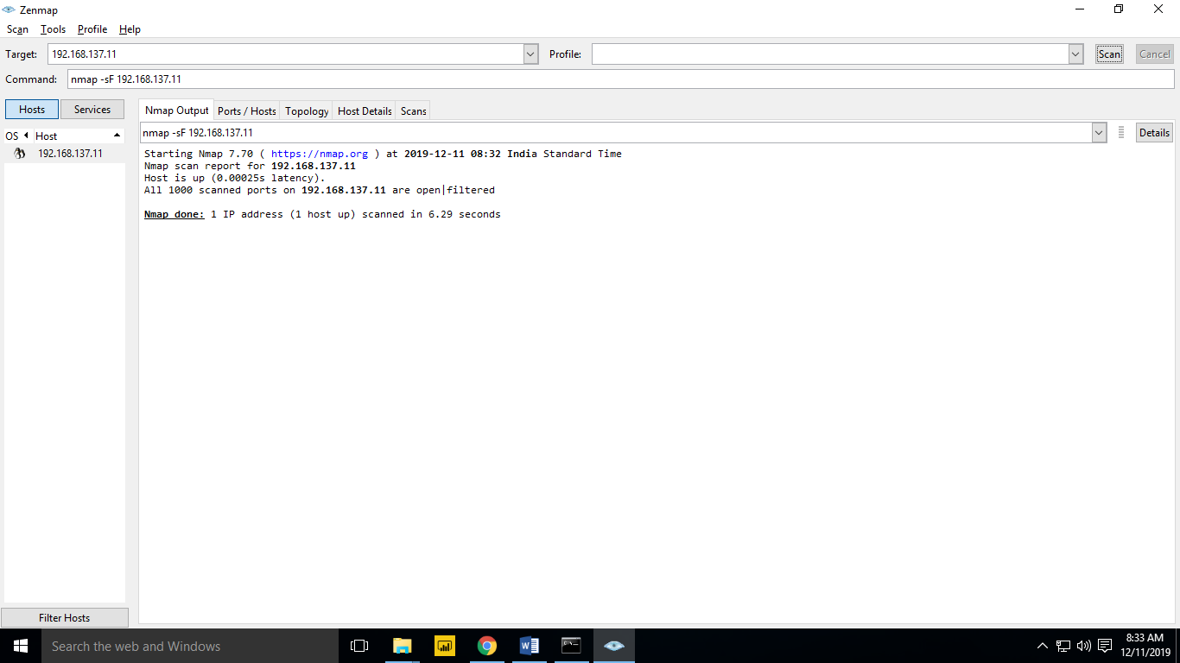

NULL SCAN

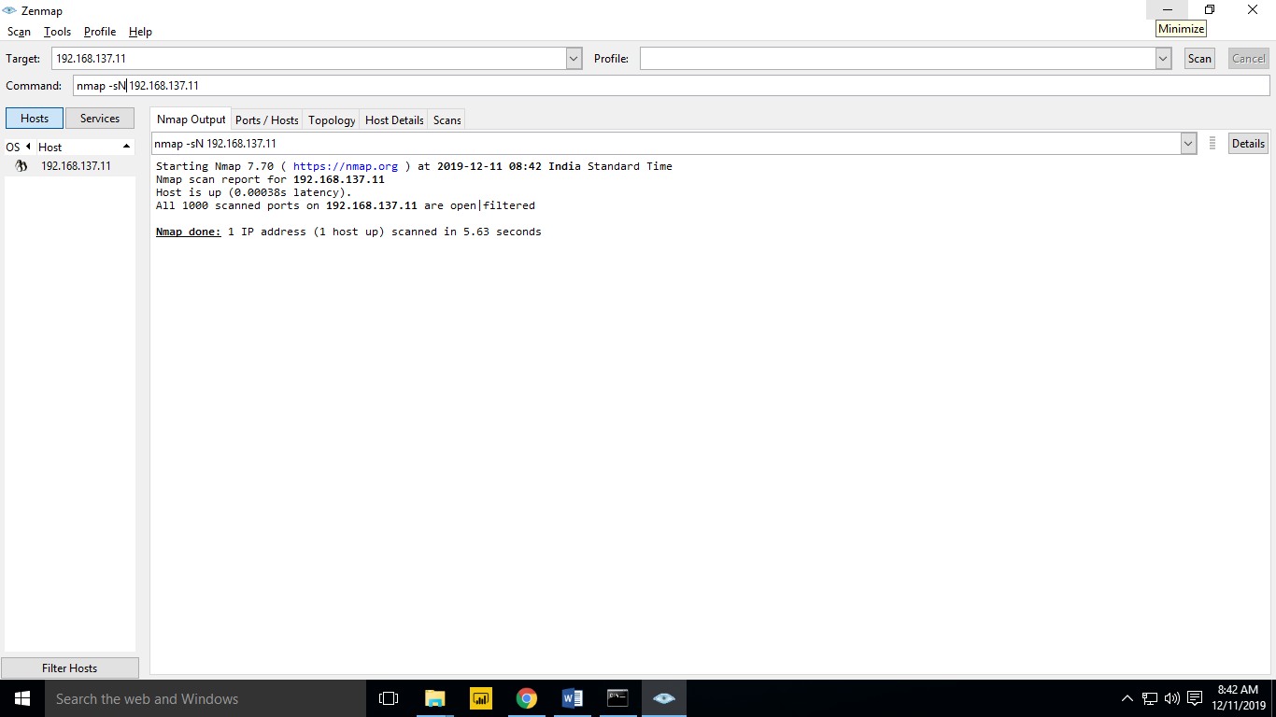

XMAS SCAN

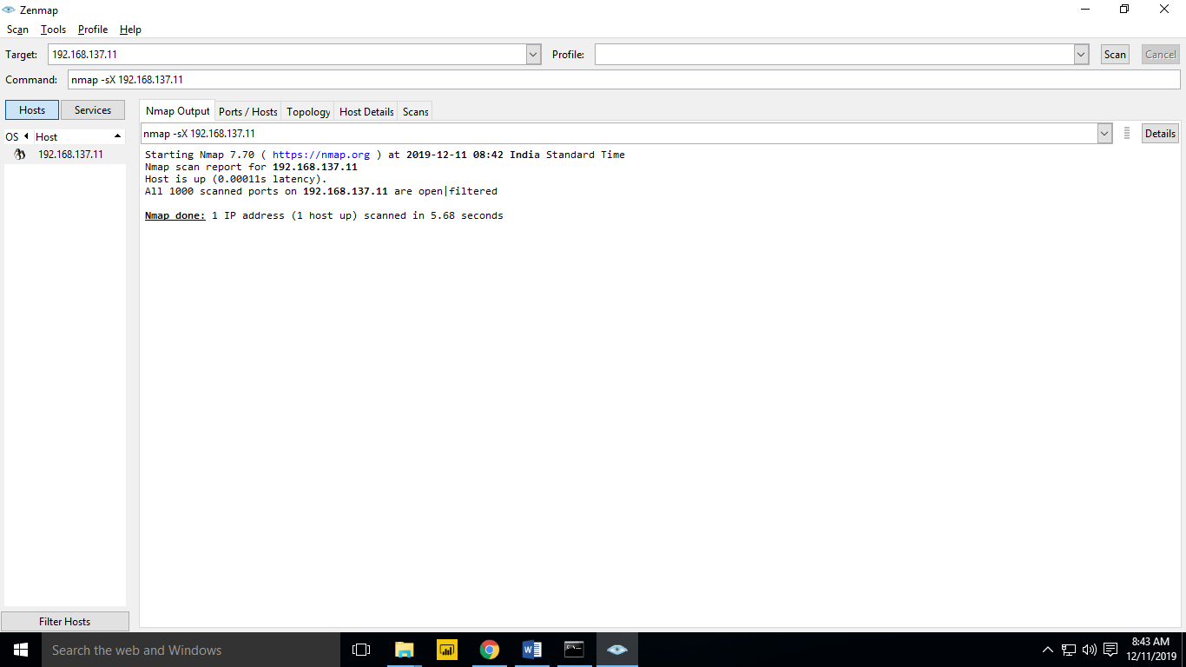

SYNC SCAN

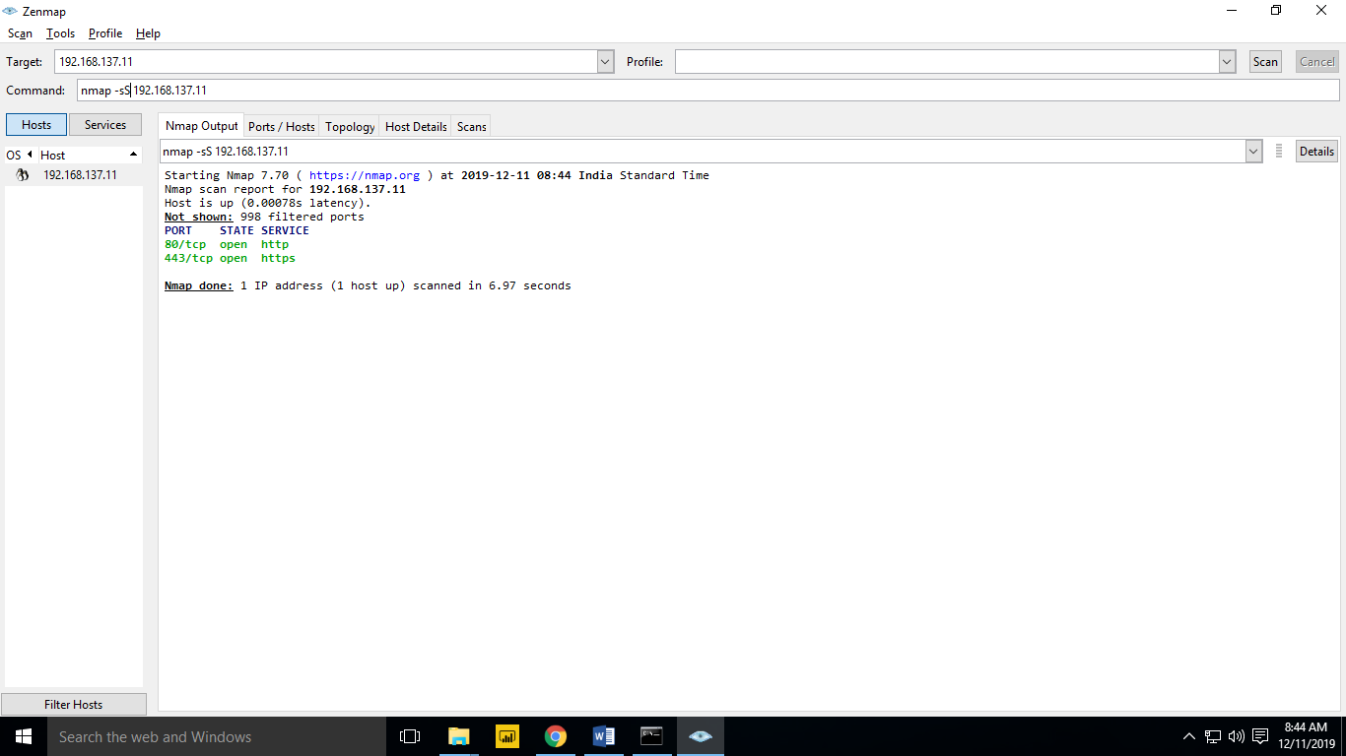

ACK SCAN

